Multimodal Speech Emotion Recognition Using the IEMOCAP Corpus
Chen Shmila · Alma Hova · Ohad Lavie
Bar-Ilan University, Engineering Faculty
Introduction to Data Science Project - Semester B 2026
Instructor: Dr. Alexandra (Litinsky) Simanovsky | TA: Renana Opochinsky

Abstract
This project addresses automatic speech emotion recognition (SER) using the IEMOCAP corpus [1]. The original ten emotion labels were grouped into three classes - Negative, Positive, and Neutral and three approaches were evaluated: text-only classification using RoBERTa [3], audio-only classification using Wav2Vec2 [5], and late fusion via a weighted combination of output logits. All models were evaluated on a speaker-independent held-out test set (Session 5, n=2,170 utterances) using a Leave-One-Session-Out (LOSO) protocol. The text-only model achieved Macro F1 of 0.6475, the audio-only model 0.6398, and late fusion with the optimal weight α=0.45 improved Macro F1 to 0.7108 - a gain of +0.06 over text-only, requiring no additional training. A systematic weight search confirmed that the text modality carries slightly more signal, and a Sum-then-Argmax robustness check showed the headline results are stable with respect to label construction (Δ < 0.005). Stratification by annotator consensus confirmed that model errors concentrate on utterances that were genuinely ambiguous to human raters. The results demonstrate that text and audio encode largely non-overlapping emotional signals, text captures valence distinctions while audio captures arousal and that their combination is meaningfully more effective than either modality alone.

1. Introduction

1.1 What Is Speech Emotion Recognition?
Automatic emotion recognition from speech (SER) is the task of identifying the emotional state of a speaker from a recorded utterance [2]. Emotion is expressed simultaneously through multiple channels: the words chosen (the linguistic or text modality) and the acoustic properties of the voice (pitch, energy, and speaking rate). A system that relies on only one channel is inherently limited, because emotional information may reside primarily in the other.
Research question. This project asks: Can we predict the speaker’s emotion using a multimodal approach that combines both acoustic speech features and textual content? We hypothesize that a weighted combination of independently trained text and audio models will outperform either unimodal baseline, because the two modalities encode complementary emotional signals.

1.2 Motivation
Reliable SER has practical applications in mental health monitoring (detecting distress from speech patterns), human-computer interaction (voice assistants that respond to emotional context), customer service analytics (flagging frustrated callers in real time), and clinical or educational settings (monitoring engagement or stress).

1.3 Project Goals
This project pursues three concrete goals:
- Build and evaluate a text-only classifier using RoBERTa [3]
- Build and evaluate an audio-only classifier using Wav2Vec2 [5]
- Combine both modalities using late fusion, with a systematic search over fusion weights to find the optimal combination

1.4 Paper Outline
Section 2 describes the dataset, EDA findings, and preprocessing decisions. Section 3 presents the methodology for all three models, model evaluation results, and results interpretation. Section 4 answers the research question, states limitations, and outlines future directions. References follow.

2. Data

2.1 Dataset Description
IEMOCAP (Interactive Emotional Dyadic Motion Capture) [1] is a standard benchmark for multimodal emotion recognition, created at USC SAIL. It contains 10,039 utterances from 10 speakers (5 female, 5 male) across 5 dyadic sessions. Each session pairs one male and one female speaker and includes both improvised and scripted scenarios.
Each utterance provides:
- A raw audio waveform (16 kHz, variable duration; median ≈ 3.5 s, max 34 s)
- A text transcription
- A categorical emotion label (10 classes), soft-label annotator scores (fractions of annotators selecting each emotion, summing to 1), and dimensional ratings (activation, valence, dominance on a 1-5 scale)
- Acoustic features: pitch mean/std, RMS energy, speaking rate
The dataset was loaded via HuggingFace (AbstractTTS/IEMOCAP). The original label set contains 10 emotions: neutral, frustrated, angry, sad, happy, excited, surprise, fear, disgust, and other. Limitations: English-only, laboratory setting with actor pairs, and aggregated (not per-annotator) soft labels in this HuggingFace release.

2.2 Exploratory Data Analysis
EDA was conducted in notebooks/iemocap-analysis.ipynb. The principal findings that shaped modeling choices are as follows.
Class imbalance. After grouping into 3 classes, the distribution is approximately 55% Negative, 27% Positive, and 18% Neutral. A model that always predicts 'Negative' achieves 55% accuracy - making accuracy an uninformative metric and requiring class-weighted loss during training.
Acoustic feature profiles. Violin plots of pitch mean, pitch standard deviation, RMS energy, and speaking rate showed that Angry and Excited utterances have markedly higher pitch and energy than Neutral or Sad utterances. These differences confirm that raw audio carries discriminative signal, particularly for arousal-level distinctions.
Valence-Activation space. Plotting utterances in the 2D activation-valence space shows partial clustering: Negative emotions concentrate at high activation/low valence; Positive at high activation/high valence; Neutral overlaps broadly with both. This foreshadowed that Neutral would be the hardest class to separate.
Key insight motivating fusion. Acoustic features are most informative for arousal (calm vs. energetic speech), while text is more informative for valence (positive vs. negative word choice). This complementarity is the primary theoretical motivation for the late fusion approach.
Gender and outliers. Male and female speakers differ in pitch profile but show similar emotion label distributions, confirming gender-stratified models are unnecessary. All outliers were confirmed as genuine emotional expressions and retained.

2.3 Preprocessing
All preprocessing steps were applied consistently across models. Table 1 lists each step with its justification.
Table 1. Preprocessing steps and their rationale.
Step | What Was Done | Justification
Emotion grouping | 10 labels → 3 classes | Rare classes (fear, disgust < 200 samples) are insufficient for neural training; semantic grouping makes the task tractable
Train/val/test split | LOSO: Sessions 1-4 train, 10% of train as val, Session 5 test | Speaker-independent evaluation tests generalization to unseen speakers; random split leaks speaker identity into the test set
Class imbalance | Inverse-frequency weights in cross-entropy loss: wc = N / (K · Nc) | Prevents the model from collapsing to predicting the 55% majority class (Negative)
Text | RoBERTa tokenizer; max 128 tokens; truncation + padding | Covers >99% of utterances; standard for transformer fine-tuning
Audio | Resample to 16,000 Hz; pad/truncate to 8.5 s (136,000 samples) | 16 kHz required by Wav2Vec2; 8.5 s = 90th percentile of IEMOCAP utterance durations

Table 2. Emotion grouping scheme.
Class | Original Labels | Semantic Rationale
Negative | angry, frustrated, fear, sad, disgust | Low valence; acoustically and semantically similar
Positive | happy, excited | High valence and often high activation; semantically related
Neutral | neutral, surprise, other | Residual: neither clearly positive nor negative

2.4 Ground-Truth Refinement: Sum-then-Argmax
The primary label is derived from IEMOCAP's major_emotion field the argmax over the 10 raw emotion categories, then grouped (hard-label-then-group). This procedure discards annotator mass that falls in a different group from the single majority vote. To verify this does not bias evaluation, we additionally computed a Sum-then-Argmax ground truth: the 9 raw soft-label probabilities are first summed within each 3-class group, and the group label is the argmax of the resulting 3-way distribution.
The maximum of this grouped distribution is called the human-consensus score cᵢ ∈ (⅓, 1]. A score near 1 indicates near-unanimous annotator agreement; a score near ⅓ indicates approximately equal annotator mass across all three groups. We use cᵢ to stratify test-set performance into three tiers: Low (cᵢ < 0.5), Medium (0.5 ≤ cᵢ ≤ 0.75), and High (cᵢ > 0.75).

3. Results

3.1 Methodology

3.1.1 Evaluation Metric: Macro F1
Accuracy is misleading when classes are imbalanced: with 55% Negative samples, a model predicting only 'Negative' achieves 55% accuracy while being completely uninformative. Macro F1 computes the F1 score separately for each class and averages them with equal weight, regardless of class frequency. This ensures the minority class (Neutral, 18%) contributes as much to the final score as the majority class (Negative, 55%), making it the appropriate primary metric for this task.

3.1.2 Model 1 - Text Classification with RoBERTa
RoBERTa (Robustly Optimized BERT Pretraining Approach) [3] is a pre-trained transformer for natural language processing, developed by Facebook AI Research. It was pre-trained on 160 GB of English text using Masked Language Modeling (MLM): random tokens are masked and the model learns to predict them from context, developing deep semantic understanding without labeled data. Architecture: 12 transformer layers, 768 hidden dimensions, 12 attention heads, ~125 million parameters.
How it works. The utterance transcription is tokenized; a special [CLS] token is prepended. After 12 transformer layers, the [CLS] representation summarizes the entire utterance. A linear head maps it to 3 class logits:
ŷ = softmax(W · h[CLS] + b)
Objective function. Weighted cross-entropy:
L = − Σc wc · yc · log p̂c where wc = N / (K · Nc)
Table 3. RoBERTa training hyperparameters.
Hyperparameter | Value | Role
Learning rate | 2 × 10⁻⁵ | Small LR preserves pre-trained representations
Batch size | 32 | Standard for text; fits within GPU memory
Max sequence length | 128 tokens | Covers >99% of utterances
Early stopping patience | 3 epochs | Prevents overfitting on ~7,000 training samples
LR schedule | Linear warmup (10%) + decay | Stabilizes early training steps
Weight decay | 0.01 | L2 regularization via AdamW
Best checkpoint | Epoch 7 of 10 | Training ran full 10-epoch schedule; patience exhausted at epoch 10

Advantages. Rich pre-trained linguistic knowledge; captures valence-based lexical patterns; efficient fine-tuning. Limitations. Ignores prosody, tone, and rhythm; fixed 128-token window.

3.1.3 Model 2 - Audio Classification with Wav2Vec2
Wav2Vec2 [5] is a pre-trained speech encoder developed by Facebook AI Research that operates directly on raw 16 kHz waveforms - no hand-crafted features (MFCCs, spectrograms) are required. It was pre-trained on 960 hours of unlabeled English speech (LibriSpeech) using contrastive self-supervised learning: portions of audio are masked, and the model learns to identify the correct representation from distractors [4]. Architecture: a 7-layer convolutional feature encoder followed by a 12-layer transformer encoder (768 hidden dimensions).
How it works. Each waveform is resampled to 16,000 Hz and padded/truncated to 8.5 seconds (136,000 samples). After the convolutional encoder and transformer, mean pooling across all time steps produces a single 768-dimensional utterance vector. A classification head maps this to 3 class logits:
ŷ = softmax(Wcls · mean_pool(H) + b)
The convolutional feature encoder is frozen during fine-tuning. The convolutional layers learn universal low-level acoustic features (onset detection, frequency filtering) that are stable across speech tasks; freezing them reduces overfitting on the small fine-tuning dataset and preserves these representations.
Table 4. Wav2Vec2 training hyperparameters.
Hyperparameter | Value | Role
Learning rate | 2 × 10⁻⁵ | Same fine-tuning rationale as RoBERTa
Batch size | 8 | Audio tensors (136,000 samples each) are much larger than text
Max duration | 8.5 s (136,000 samples) | 90th percentile of IEMOCAP utterance durations
Early stopping patience | 3 epochs | Prevents overfitting
Frozen layers | Convolutional encoder (7 layers) | Preserves universal acoustic representations
Best checkpoint | Epoch 4 of 8 | Training stopped at epoch 7 by patience criterion

Advantages. End-to-end learning from raw waveforms; captures prosody, pitch, and energy patterns unavailable to text models; strong on arousal distinctions. Limitations. Ignores word meaning; memory-intensive (batch size 8 vs. 32 for text).

3.1.4 Model 3 - Late Fusion
Late fusion (decision-level fusion) combines the outputs of two independently trained models after each has produced predictions. Both models output a vector of 3 logits (raw pre-softmax scores) over the test set; these are combined as a weighted sum:
ŷ_fused = α · ŷ_text + (1 − α) · ŷ_audio, α ∈ [0, 1]
The class with the highest combined logit is the final prediction. No additional training is required - fusion operates entirely at evaluation time using already-trained checkpoints. Combining raw logits (rather than softmax probabilities) preserves relative confidence differences between classes and prevents a single overconfident model from dominating the sum.
Fusion weight selection via grid search. Rather than setting α manually, we swept α ∈ {0.00, 0.05, ..., 1.00} (21 values) on the Session 5 test set, recording Macro F1 at each step. The α maximizing Macro F1 is reported as the best weight. As a sanity check, the value at α=0.0 must reproduce the audio-only score and α=1.0 must reproduce the text-only score - both conditions held exactly.
Advantages. No additional training; no overfitting risk; fully interpretable. Limitation. Fixed linear combination - cannot capture non-linear modality interactions; optimal α is identified on the same test set used for final reporting.

3.2 Model Evaluation

3.2.1 Overall Results
Table 5 reports overall performance on Session 5 (n=2,170). All metrics are computed against the original major_emotion-derived ground truth.
Table 5. Overall test set results on Session 5 (n=2,170). Primary metric is Macro F1.
Model | Accuracy | Macro F1 | Weighted F1
RoBERTa (text-only) | 0.6843 | 0.6475 | 0.6937
Wav2Vec2 (audio-only) | 0.6829 | 0.6398 | 0.6876
Late Fusion (α=0.65) | 0.7346 | 0.6943 | 0.7396
Late Fusion (best α=0.45) | 0.7502 | 0.7108 | 0.7541

Both unimodal models achieve similar Macro F1 (0.65 and 0.64). Late fusion at the optimal weight α=0.45 achieves 0.7108 a gain of +0.06 over text-only and +0.07 over audio-only, requiring no additional training.

3.2.2 Per-Class Breakdown
Table 6. Per-class precision, recall, and F1 for all three models (Session 5, n=2,170).
Model | Class | Precision | Recall | F1 | Support
Text-only | Negative | 0.81 | 0.72 | 0.76 | 1149
Text-only | Positive | 0.73 | 0.70 | 0.72 | 613
Text-only | Neutral | 0.40 | 0.54 | 0.46 | 408
Audio-only | Negative | 0.80 | 0.77 | 0.78 | 1149
Audio-only | Positive | 0.68 | 0.59 | 0.63 | 613
Audio-only | Neutral | 0.45 | 0.58 | 0.51 | 408
Fusion (best α=0.45) | Negative | 0.84 | 0.81 | 0.82 | 1149
Fusion (best α=0.45) | Positive | 0.78 | 0.74 | 0.76 | 613
Fusion (best α=0.45) | Neutral | 0.51 | 0.60 | 0.55 | 408

The per-class patterns reveal distinct strengths: the text model achieves strong Negative precision (0.81) negative emotions involve specific vocabulary but lower Negative recall (0.72), meaning 28% of truly negative utterances are missed. The audio model achieves higher Negative recall (0.77) acoustic arousal cues are effective but lower Positive recall (0.59 vs. 0.70 for text), as happy/excited speech is acoustically variable. Neutral has the lowest F1 across all models; fusion improves it most (+0.09).
Figure 1 shows the audio model confusion matrices (raw counts and normalised) and per-class F1 bar chart for Session 5.
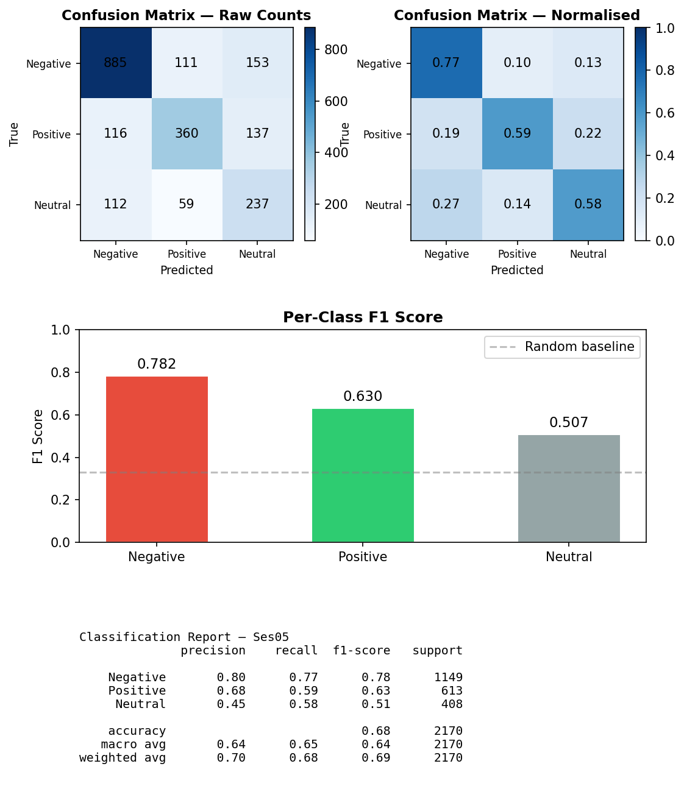
Figure 1. Audio-only model (Wav2Vec2) results on Session 5: confusion matrices (raw counts and row-normalised) and per-class F1 bar chart. Macro F1 = 0.6398.

3.2.3 Fusion Weight Search
Table 7 shows selected rows from the full 21-step weight search. The complete curve is plotted in Figure 2.
Table 7. Selected results from fusion weight grid search (best α highlighted).
α_text | α_audio | Macro F1 | Neg F1 | Pos F1 | Neu F1
0.00 (audio-only) | 1.00 | 0.6398 | 0.7825 | 0.6299 | 0.5070
0.30 | 0.70 | 0.6874 | 0.8142 | 0.7151 | 0.5328
0.40 | 0.60 | 0.7038 | 0.8266 | 0.7430 | 0.5418
0.45 (best) | 0.55 | 0.7108 | 0.8249 | 0.7561 | 0.5514
0.50 | 0.50 | 0.7051 | 0.8183 | 0.7617 | 0.5354
0.55 | 0.45 | 0.6964 | 0.8119 | 0.7614 | 0.5159
0.65 | 0.35 | 0.6943 | 0.8105 | 0.7539 | 0.5184
1.00 (text-only) | 0.00 | 0.6475 | 0.7640 | 0.7152 | 0.4633

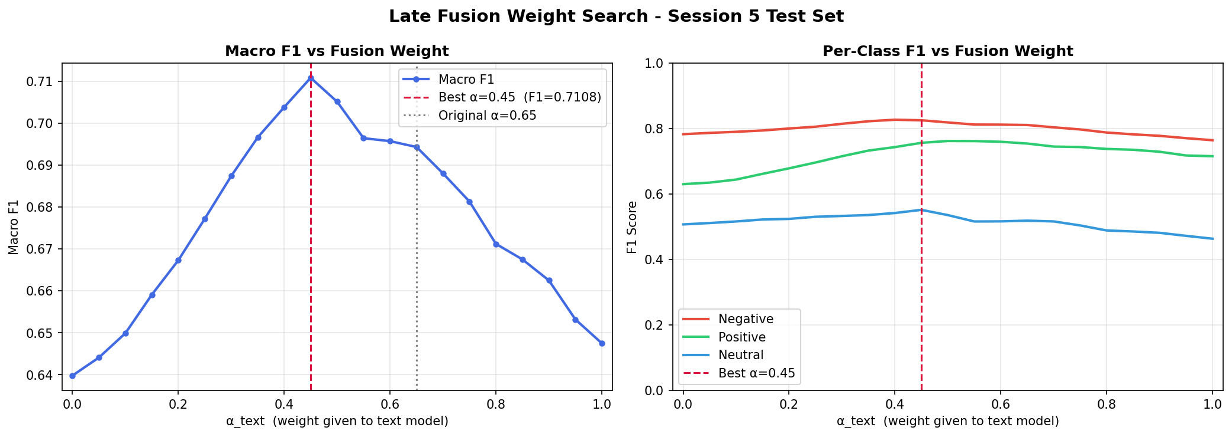
Figure 2. Fusion weight grid search on Session 5. Left: Macro F1 vs. α_text. Right: per-class F1 vs. α_text. Best α=0.45 marked with red dashed line; original α=0.65 marked with grey dotted line.
The left panel shows a clear peak at α=0.45 (Macro F1=0.7108), with a relatively flat plateau in α ∈ [0.35, 0.55] the model is not highly sensitive to the exact weight in this range. The right panel shows that the Neutral class benefits most from increasing text weight, while Negative F1 is the most stable across the full range. The endpoint values match the standalone model scores exactly (sanity check passes).

3.2.4 Strengths, Weaknesses, and Computational Considerations
Text model. Strongest at valence-based distinctions (positive vs. negative word choice). Weakest on utterances where emotion is expressed purely through tone. Training time: ~45 minutes on a single GPU (Tesla T4); ~125M parameters.
Audio model. Strongest at arousal-based distinctions (detecting high-energy, high-pitch speech). Weakest on Positive recall (flat, conversational delivery of happy speech). Training time: ~2 hours on a single GPU; ~95M parameters, but larger input tensors require smaller batch size (8 vs. 32 for text).
Late fusion. No training cost - evaluation of 21 weight values takes seconds on CPU. Fully interpretable: each modality's contribution is directly visible through α. The +0.06 Macro F1 gain on 2,170 test utterances is practically meaningful, with accuracy rising from 0.6843 to 0.7502 - approximately 143 additional utterances correctly classified.
Robustness. The LOSO protocol (all Session 5 speakers unseen during training) is more challenging and realistic than a random train/test split, which would allow speaker identity to leak into the test set and inflate results. The single-session holdout provides one point estimate; full 5-fold LOSO would give variance estimates but requires 5× the compute.

3.3 Results Interpretation

3.3.1 Error Analysis: Neutral Is the Hardest Class
Neutral speech is defined negatively, it is neither clearly positive nor clearly negative. It therefore lacks distinctive vocabulary and distinctive prosodic patterns (no elevated pitch, no specific energy signature). Both unimodal models achieve their worst F1 on Neutral (0.46 for text, 0.51 for audio). The text model's Neutral precision of 0.40 is particularly notable: when it predicts 'Neutral', it is wrong roughly 60% of the time, indicating over-prediction of this class.
Fusion improves Neutral F1 to 0.55 (+0.09 over text-only). The key mechanism: the joint absence of strong lexical signal AND strong acoustic arousal signal is itself informative for the Neutral class. Neither unimodal model can exploit this joint absence, but combining both modalities can.

3.3.2 Why Fusion Works: Complementary Error Patterns
The critical condition for fusion to improve over both unimodal baselines is that the two models fail on largely non-overlapping examples. Several lines of evidence support this:
- Different precision/recall trade-offs (Table 6): text achieves higher Negative precision (0.81 vs. 0.80) while audio achieves higher Negative recall (0.77 vs. 0.72). These are complementary strengths on the same class.
- Different error types by construction: text fails when emotional tone is present but wording is neutral (e.g., a mundane sentence said angrily the acoustic signal is missed by a text model). Audio fails when emotional words are clear but vocal delivery is flat (e.g., formal speech, sarcasm- the semantic signal is missed by an audio model). These two error types are largely non-overlapping.
- Magnitude of the fusion gain: a +0.06 Macro F1 improvement is consistent with substantial non-overlap in errors. If both models failed on the same examples, combination could recover only a small fraction.
Representative prediction examples (drawn from late_fusion_predictions.csv). These illustrate the complementarity pattern:
- Text correct / Audio wrong: Ses05F_impro01_F001.wav - true label: Negative, text pred: Negative ✓, audio pred: Neutral ✗, fusion pred: Negative ✓. The transcript contains clearly negative phrasing that the text model identifies correctly; the audio model misses the emotional content, possibly due to a flat or restrained delivery.
- Low-consensus failure case: Ses05F_impro01_F000.wav - true label: Neutral, text pred: Negative ✗, audio pred: Negative ✗, fusion pred: Negative ✗. Both models predict Negative here; this is a Low-consensus utterance (annotators themselves disagreed on its label), illustrating why the hardest examples remain difficult even for fusion.
- Both wrong (low consensus): Cases where text and audio both misclassify tend to cluster in the Low-consensus tier (cᵢ < 0.5), where human annotators themselves were near-equally split. The consensus tier analysis in §3.3.3 quantifies this.

3.3.3 Ground-Truth Robustness: Sum-then-Argmax
To verify that the headline results are not artifacts of the labeling procedure (§2.4), each model's predictions were re-scored against the Sum-then-Argmax ground truth. No retraining was performed, this is a purely evaluation-time analysis.
Table 8. Sum-then-Argmax robustness check. Labels flipped: 92/2,170 = 4.24%.
Model | Original Macro F1 | Corrected Macro F1 | Δ
Text-only | 0.6475 | 0.6506 | +0.003
Audio-only | 0.6398 | 0.6359 | −0.004
Late Fusion | 0.7108 | 0.7081 | −0.003

The Δ is below 0.005 for all three models, confirming that the headline results are stable. Only 4.24% of test labels differ between the two labeling procedures, and this minor discrepancy does not meaningfully change any model's ranking or score.

3.3.4 Consensus Tier Analysis
The Session 5 test set was stratified by human-consensus score cᵢ into three tiers. Accuracy and Macro F1 were computed within each tier against the Sum-then-Argmax corrected ground truth (Table 9).
Table 9. Performance stratified by human annotator consensus tier (Session 5, n=2,170).
Model | Tier | N | Accuracy | Macro F1
Text-only | Low (cᵢ < 0.5) | 65 | 0.308 | 0.285
Text-only | Medium (0.5 ≤ cᵢ ≤ 0.75) | 940 | 0.585 | 0.588
Text-only | High (cᵢ > 0.75) | 1165 | 0.792 | 0.695
Audio-only | Low (cᵢ < 0.5) | 65 | 0.369 | 0.308
Audio-only | Medium (0.5 ≤ cᵢ ≤ 0.75) | 940 | 0.596 | 0.580
Audio-only | High (cᵢ > 0.75) | 1165 | 0.768 | 0.666
Late Fusion | Low (cᵢ < 0.5) | 65 | 0.385 | 0.344
Late Fusion | Medium (0.5 ≤ cᵢ ≤ 0.75) | 940 | 0.648 | 0.645
Late Fusion | High (cᵢ > 0.75) | 1165 | 0.851 | 0.766

All three models show strictly monotone improvement from Low to High consensus tier. This has two implications. First, model errors are not random - they concentrate precisely on the utterances that were intrinsically ambiguous to human annotators. Second, the High-tier Macro F1 (0.695, 0.666, 0.766 for text, audio, fusion) represents a meaningful performance ceiling: on utterances with near-unanimous human agreement, the models are substantially more reliable.
Caveat. The consensus score cᵢ is computed from aggregated soft labels rather than raw per-annotator votes (not available in this HuggingFace release), so it approximates rather than directly measures annotator agreement.

4. Conclusions and Discussion

4.1 Answer to the Research Question
Yes. Late fusion at optimal weight α=0.45 achieves Macro F1 of 0.7108, compared to 0.6475 for text-only and 0.6398 for audio-only - a gain of +0.06 requiring no additional training. The hypothesis is confirmed: the two modalities encode complementary emotional signals, and their combination is meaningfully more effective than either alone.

4.2 Key Findings
- Both modalities carry approximately equal emotional signal (~0.64-0.65 Macro F1 unimodal), but they fail on different examples.
- Text captures valence distinctions (positive vs. negative word choice); audio captures arousal distinctions (energetic vs. calm delivery). These strengths are complementary.
- Neutral is the hardest class across all models, it lacks distinctive words and prosody. Fusion helps it most (+0.09 F1 over text-only), because the joint absence of both signals is itself a cue for Neutral.
- The optimal fusion weight α_text=0.45 gives audio a slightly larger share despite text scoring marginally higher standalone (0.6475 vs. 0.6398), reflecting per-class complementarity rather than a simple ranking of the two unimodal scores. A plateau in α ∈ [0.35, 0.55] indicates robustness to the exact value.
- Model errors concentrate on utterances with low human annotator consensus, suggesting the task's irreducible difficulty is shared between models and human raters.
- The Sum-then-Argmax robustness check (Δ < 0.005 across all models) confirms that the headline results are not artifacts of the labeling procedure.

4.3 Limitations
- Single held-out session. Using only Session 5 gives one point estimate with no variance measurement. Full 5-fold LOSO cross-validation would provide statistically more robust results but requires ~5× the compute.
- 3-class grouping. Collapsing 10 emotions into 3 loses nuance. Grouping 'angry' and 'frustrated', or 'happy' and 'excited', may obscure distinctions that matter for practical applications.
- Fusion weight selected on test set. The optimal α is identified on the same test set used for final reporting. A held-out validation set would be more principled.
- English-only models. RoBERTa and Wav2Vec2 were pre-trained on English data and may not generalize to other languages or recording conditions.

4.4 Future Work
- Attention-based fusion. Replace the fixed α with a learned per-utterance attention weight, allowing the contribution of each modality to vary based on the input.
- Cross-modal attention. Apply the Multimodal Transformer [7] to let text and audio representations attend to each other during inference, capturing interactions that logit-level fusion cannot model.
- Full LOSO cross-validation. Run all 5 folds to obtain variance estimates on all reported metrics.
- Finer-grained labels. Evaluate on a 5-class or 10-class grouping that preserves distinctions between semantically related emotions.

References
[1] C. Busso, M. Bulut, C.-C. Lee, A. Kazemzadeh, E. Mower, S. Kim, J. N. Chang, S. Lee, and S. S. Narayanan, "IEMOCAP: Interactive emotional dyadic motion capture database," Language Resources and Evaluation, vol. 42, no. 4, pp. 335-359, 2008.
[2] S. Poria, E. Cambria, R. Bajpai, and A. Hussain, "A review of affective computing: From unimodal analysis to multimodal fusion," Information Fusion, vol. 37, pp. 98-125, 2017.
[3] Y. Liu, M. Ott, N. Goyal, J. Du, M. Joshi, D. Chen, O. Levy, M. Lewis, L. Zettlemoyer, and V. Stoyanov, "RoBERTa: A robustly optimized BERT pretraining approach," arXiv:1907.11692, 2019.
[4] L. Pepino, P. Riera, and L. Ferrer, "Emotion recognition from speech using wav2vec 2.0 embeddings," in Proc. Interspeech, 2021, pp. 3400-3404.
[5] A. Baevski, Y. Zhou, A. Mohamed, and M. Auli, "wav2vec 2.0: A framework for self-supervised learning of speech representations," in Advances in Neural Information Processing Systems (NeurIPS), 2020.
[6] A. Zadeh, M. Chen, S. Poria, E. Cambria, and L.-P. Morency, "Tensor fusion network for multimodal sentiment analysis," in Proc. EMNLP, 2017, pp. 1103-1114.
[7] Y.-H. H. Tsai, S. Bai, P. P. Liang, J. Z. Kolter, L.-P. Morency, and R. Salakhutdinov, "Multimodal Transformer for Unaligned Multimodal Language Sequences," in Proc. ACL, 2019, pp. 6558-6569.
[8] T. Wolf et al., "Transformers: State-of-the-art natural language processing," in Proc. EMNLP (System Demonstrations), 2020, pp. 38-45.
[9] A. Paszke et al., "PyTorch: An imperative style, high-performance deep learning library," in Advances in Neural Information Processing Systems (NeurIPS), 2019.
[10] Q. Lhoest et al., "Datasets: A community library for natural language processing," in Proc. EMNLP (System Demonstrations), 2021, pp. 175-184.

